ECEAP
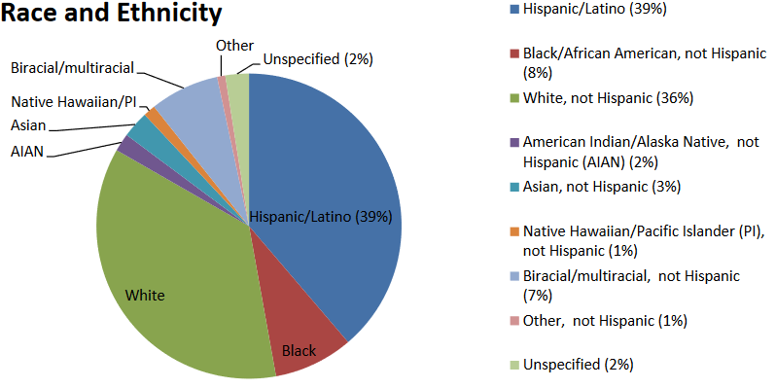

Note: ECEAP reports that:
11% of ECEAP Families report an education level of 6th Grade or Less

30% have an education level of Less than High School Diploma/GED

