ECEAP Outcomes – children AT or ABOVE expected age level
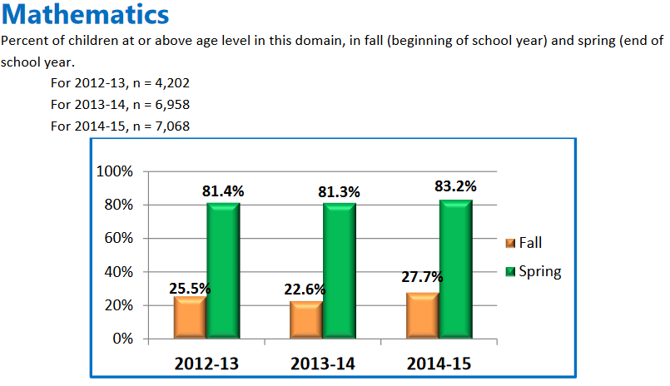

ECEAP Outcomes – children AT or ABOVE expected age level
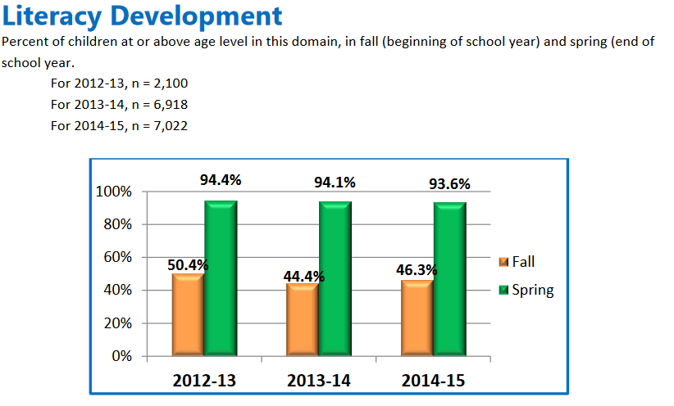

ECEAP Outcomes – children AT or ABOVE expected age level
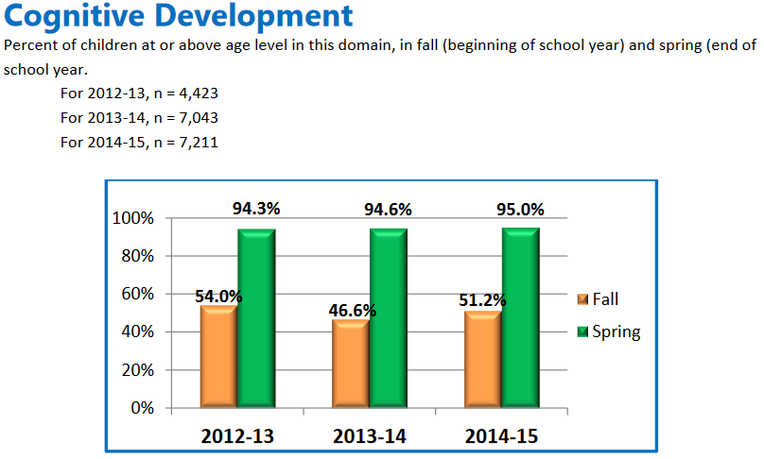
ECEAP Outcomes – children AT or ABOVE expected age level
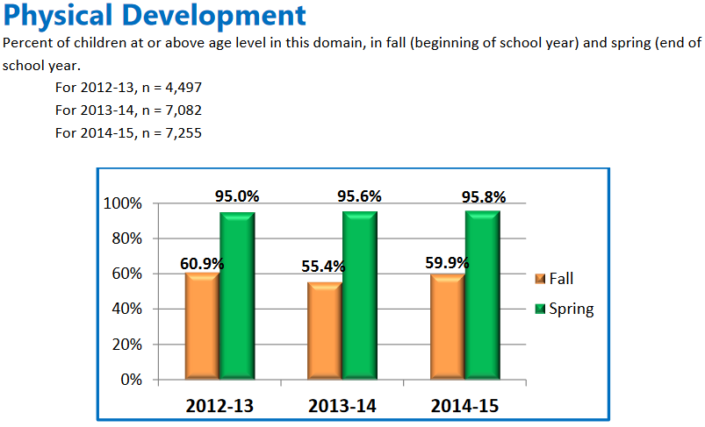

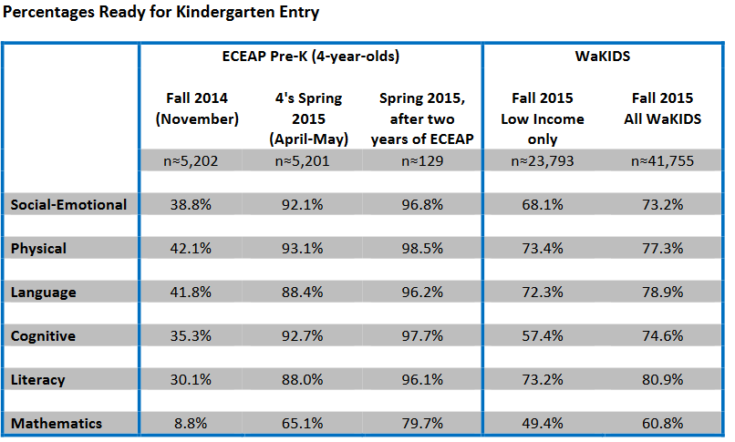

WaKIDS Kindergarten Assessment – % “Kindergarten Ready”
