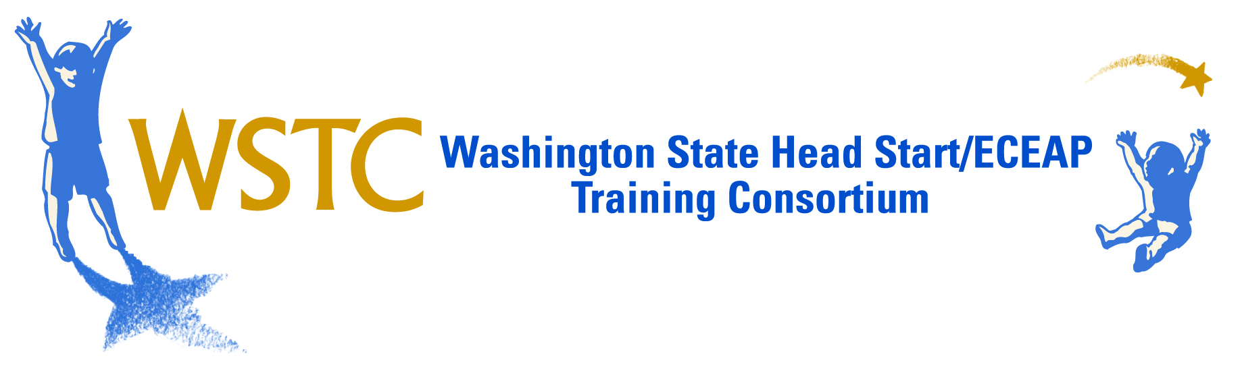

2015 WSTC SUMMER INSTITUTE

June 22-24, 2015

CWU Conference Program, Ellensburg, WA

REGISTRATION DEADLINE: June 2, 2015

It’s time again for the Washington State Head Start/ECEAP Training Consortium’s annual Summer Institute. We’re very excited about this year’s expanded offerings, and look forward to providing very high quality intensive 20-hour courses to our members and the Early Learning community at large.
Based on our survey of the membership and discussions with our programs and partners in Early Learning, we are offering the following eight courses at the 2015 Summer Institute:
- Reflective Supervision
- Ready to Learn- Neurodevelopmental Movement for Early Childhood
- Trauma Informed Care: Partnering with Early Learning Professionals around the provision of trauma sensitive practices
- Classroom Management 101
- Using Assessment Data to Intentionally Plan for Children
- All 4 Math in Early Childhood
- Poverty in the 21st Century: Opening the Door to Economic and Educational Opportunities for Children and Families
- Early Head Start For Classroom and Home-Based
- Parent Ambassadors (invitation only)

A more detailed description of courses and instructors will be sent shortly, and will be available at www.wsaheadstarteceap.com. Participants will also enjoy a barbecue or special event one evening, a movie night, and other activities.

Attached is the registration information and form to be sent to Central Washington University. The CWU Conference center administers the Summer Institute registration, lodging, etc, while WSTC handles the curriculum, so the registration form is a little confusing. Each registrant will pay a fee to CWU that includes:

- WSTC registration fee. $135 fee for members & ECEAP, $255 for non-members, which goes to WSTC to pay for trainer fees and expenses, A/V, WSTC staff and meeting room costs.
- CWU conference/lodging/meal fee. Everyone must pick one package off this list. This pays for food, lodging, conference registration and staffing, and most meeting room costs.
Clock hours, STARS credit and CEU’s will also be offered, but are paid separately at on-site registration.

For more information, contact Katy Warren at 425-453-1227, katy@wsaheadstarteceap.com.

2015 FEE DETAILS

Choose One – WSTC Summer Institute Registration Fee
WSTC Members & ECEAP $135
Others (AI/AN, Non WSTC Members, Non HS/ECEAP, etc) $255

Choose One – CWU Conference Service/Lodging/Meals
Full Packages (3 lunches, 2 breakfasts, 2 dinners, conference service)
Sue Lombard Double Occupancy $250.50
Sue Lombard Single Occupancy $313.50
Kamola Double Occupancy $232.50
Kamola Single Occupancy $278.50

Commuter Packages (limited meals, conference service, no lodging)
5 meals (lunches, dinners, conf. service) $181
3 meals (lunches, conference service) $147
0 meals (conference service only) $107

Optional – Additional Night Lodging (includes full breakfast 6/22
Single Occupancy $98
Double Occupancy $68
Optional – Credit/Clock Hours
Paid separately, during on-site registration.
Clock hours (20), Continuing Education Credits (2)

LODGING INFORMATION
Sue Lombard Hall is a newly renovated residence hall, air conditioned, and suite style units with private bathrooms shared by 2-4 bedrooms all with twin beds.
Kamola Hall rooms are double occupancy residence hall style rooms with shared bathrooms by each floor and not every floor is air-conditioned. Sleeping rooms are furnished with twin beds.

Lodging at Local Hotels – You are responsible for making your own room reservations and for payment of your stay at the hotel. If you stay at a hotel, you may inquire about any discount for attending the conference at CWU. Ellensburg Inn 800-321-8791; Comfort Inn (509) 925-7037; Days Inn (509) 933-1500, Holiday Inn Express (509)-962-9400

DEADLINES/ Registration Info
- Registration Deadline: June 2, 2015 – Any registrations after this date will pay $25 late fee.
- Cancellation Deadline: June 18, 2015 by 5pm ($25 cancellation fee)

To ensure accommodations, return registration with full payment by June 2, 2015. Full Payment must be made when registration is submitted. A $25 late fee will be assessed to any registrations received after June 2, 2015. Registrations received after June 2nd must include full payment plus the $25 late registration fee.

Address all mail to CWU CONFERENCE PROGRAM, 400 E University Way, ELLENSBURG, WA 98926-7592. Registrations will be accepted by fax (509) 963-1285 if purchase order (hard copy, not just PO number) or credit card number is included. A $25.00 cancellation fee will be charged for any cancellation received in writing at the Conference Program prior to 5pm on June 18, 2015. Cancellations received after 5pm on June 18 will not receive any refund. Email to CWU Conference Program: confpro@cwu.edu

Check In will be in the Vantage Room Sunday June 21, 2015 from 4:00-8:00 pm for those participants requesting an extra night lodging. Check in for all other participants will be at the Vantage Room between: 7:00-8:30 am June 22, 2015.

For questions about meals and lodging, call (800) 752-4379 or (509) 963-1141

FACILITY TIPS
- Rooms at CWU are basic – Linens and towels are provided, but no alarm clock, telephone, TV’s, and internet access. Bring a book, games, and an enthusiasm for getting together in the evening to chat with your colleagues!
- If you’re staying in Kamola Hall you might want to bring an oscillating fan from home.
- As in every facility and hotel, room temperature is hard to regulate in meeting rooms, so dress in layers.
- Classes will be all over the campus, so bring comfortable walking shoes and carry a water bottle.
- Message Number (509) 963-1141– Telephone messages for participants will be relayed to Katy Warren, who will find you.
- Reminder: All facilities at Central Washington University are non-smoking.

FOR MORE INFORMATION
Detailed course and instructor information will be available soon, and will be e-mailed to our distribution list and posted to the WSA/WSTC website, www.wsaheadstarteceap.com. If you would like to be on the email list for training and legislative updates, please go to the website and click on the ‘Stay Informed’ link on the left. For more information about the Summer Institute, about WSTC, or any other questions, please contact Katy Warren, 425-453-1227, or katy@wsaheadstarteceap.com.

WSTC HEAD START/EHS/ECEAP Summer Institute, #101-5209 June 22-24, 2015

Return This Form For Each Participant to:
CWU Conference Program, 400 E University Way, Ellensburg, WA 98926-7592,
fax 509.963.1285, confpro@cwu.edu

Name ___________________________________M_____F_____DAYTIME PHONE (____)_______________
Program Name __________________________________________________________________________
Program Address_______________________________City________________State________Zip________
Email Address (REQUIRED)___________________________________________________
SPECIAL NEEDS (Lodging or Dietary) ________________________________________________________
Roommate Choice :_____________________________________________________
WSTC Registration Fee: (all participants must CHOOSE ONE)
WA State Training Consortium/ECEAP $135 $______________
All others (non-WSTC) $255 $______________
(If you don’t know if your program is a WSTC member, contact Katy at 425.453.1227)

CWU Lodging/Meals/Conf Fee (per person, all participants must CHOOSE ONE)
Full Package Sue Lombard ____double $250.50 ____single $313.50 $______________
Kamola ____double $232.50 ____single $278.50 $______________
Commuter Package 5 meal commuter package ____ $181 $______________
3 meal commuter package ____ $147 $______________
Conference Only ____ $107 $______________

Optional Fee – Sunday Night Lodging 6/21/15 ____double $68, ___single $98 $______________

CWU Late fee for Registration after June 2, 2015 $25 $______________

TOTAL PAYMENT ENCLOSED Payable to CWU Conference Program: $______________

[ ] I will pay by Purchase Order # (hard copy must be attached to process registration)

Course Preference – Please indicate your first, second and third choices for your course selection.
Course Title | First Choice | Second Choice | Third Choice | Credit/ Clock Hours
Track 1: Reflective Supervision
Track 2: Ready to Learn- Neurodevelopmental Movement for Early Childhood
Track 3: Trauma Informed Care: Partnering with Early Learning Professionals around the provision of trauma sensitive practices
Track 4: Classroom Management 101
Track 5: Using Assessment Data to Intentionally Plan for Children
Track 6: All 4 Math in Early Childhood
Track 7: Poverty in the 21st Century: Opening the Door to Economic and Educational Opportunities for Children and Families
Track 8: Early Head Start for Classroom and Home-Based
Track 9: Parent Ambassadors (invitation only)

[ ] I will pay with Visa/MasterCard # Exp. Date
Cardholder Signature: Date

